**Capstone Design(2)**

**Final Report**



**Subjects : Capstone Design(2)**

**Prof. : Sang O Park**

**Team Name : 316**

**Members : 20163704 Park Juhyeon**

**20161344 Heo JeongWoo**

**20164245 Hong Jin**

**Contents**

1. **Project Introduction**
   1. Project Title
   2. Development Background and Goals
   3. Benefits
   4. Task sharing and Project schedule
   5. Function Introduction
   6. Development Environment
   7. Project Reference
2. **Function Implement**
   1. Project outline
   2. Development progress
3. **Project Result**
   1. Project Completion
   2. Survey Summary
   3. Future development plan
   4. Review
4. **Project Introduction**
   1. **Project Title**

Smoothie.

Our Program “Smoothie” is an Image Editing Program. It means you can easily and quickly access images from editing to lasso.

**1.2 Development Background and Goals**

There are already many image editing programs on the market. For example, Photoshop exists, but Photoshop requires a lot of proficiency. So We decided that many people wanted to use Photoshop functions quickly and easily.

Thanks to such demand and the development of computer vision technology, We have implemented automation of the Lasso Function.

Our goal is to create a fast, easy to use, and accurate image editing program.

* 1. **Benefits**

Performs the lasso function in a way that has not existed before.

If you enter the image and the keyword you want, it automatically extracts the result.

You can use the result as a sticker for easy image editing.

Furthermore, if you launch a program, you will be able to grow into a program that can meet many demands.

* 1. **Task sharing and Project schedule**

<schedule>

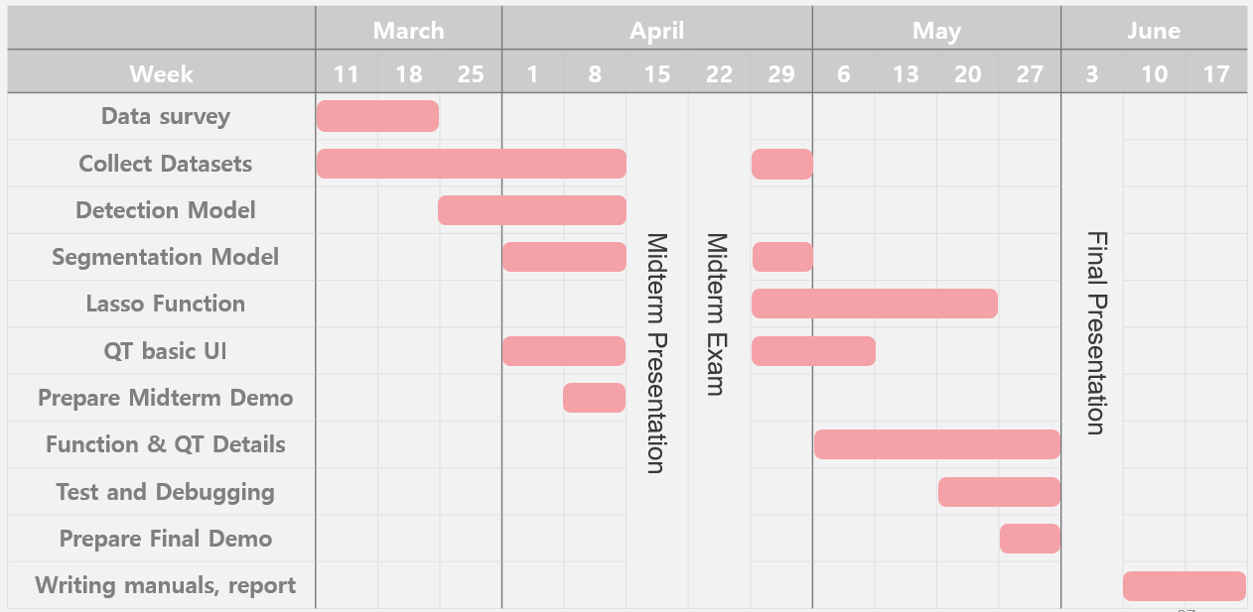

<Task Sharing>

Park Juhyeon

-Collect Running Datasets

-Implementing Detection Learning Model

-Layer Function Implementation

-Test

Heo JeongWoo

* + Collecting Running Datasets
  + Implementing Segmentation Learning Model
  + Implementing sizing
  + Test

Hong Jin

-Collecting Running Datasets

-Learning data to model

-Implementing Qt UI and basic functions

-Test

* 1. **Function Introduction**

- Lasso function

Easy and fast lasso. If you enter a keyword for 80 categories, it extracts the result for that keyword.

- Drawing Function

The drawing function provides the same functions as a normal image editing programs.

- Sticky Layer

It will provide you with the ability to make the output from the lasso wfunction like a sticker

- Other Photo Edit Programs

In addition, if provides simple functions such as zoom in and zoom out to provide convenience for the users.

* 1. **Development Environment**

QT

MinGW

AWS EC2

P2.xlarge

Tensorflow

Cuda9.0

Keras2

Python3.5

Anaconda 3

JupyterNotebook

COCO dataset

* 1. **Project Reference**

The implementation can be found on Amazon`s servers and endpoints. The contents of the server can be shown on request. (By charge Problem)

Git hub reference : https://github.com/smoothie316

1. **Function Implement**
   1. **Project outline**

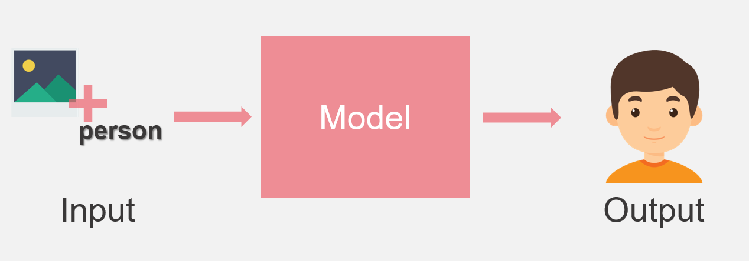

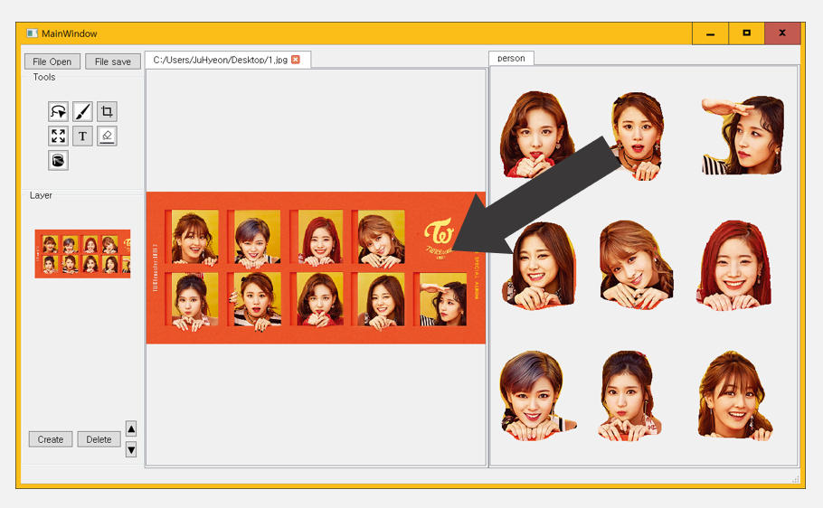

You can see the explanation of our project at a glance.

* 1. **Development progress**

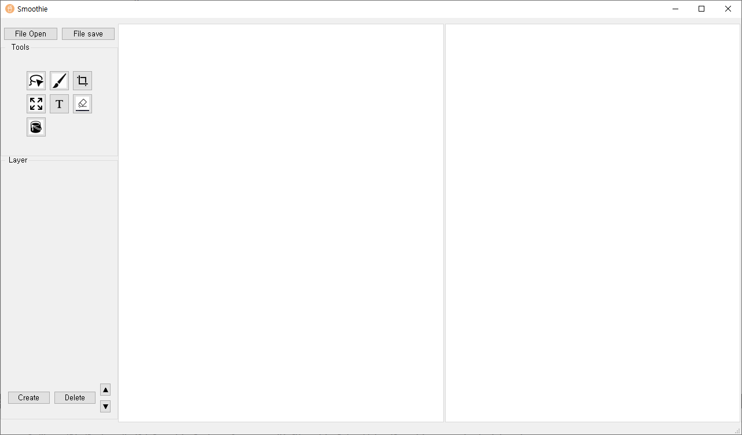

Main Window

All functions start here.

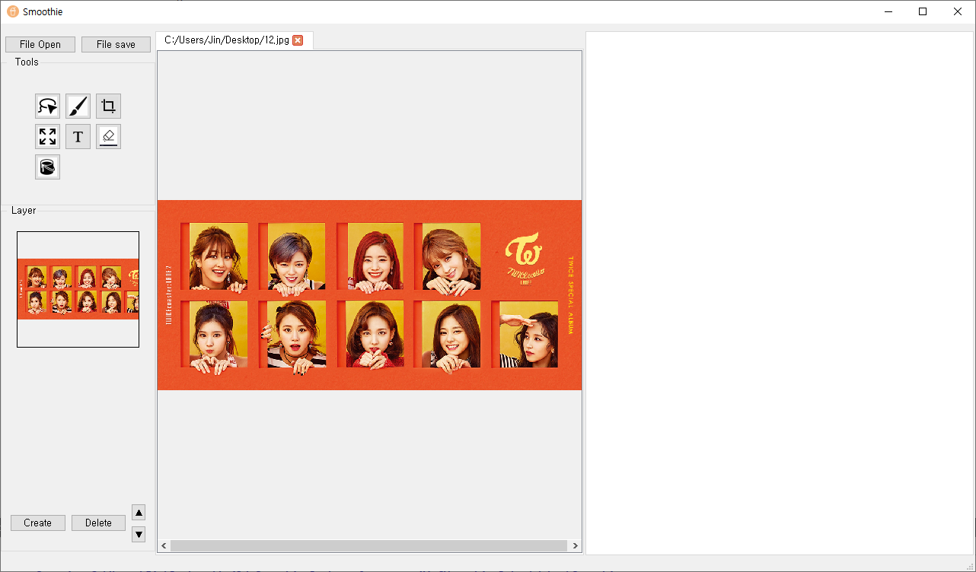

File Open

You can open the file. Several of them are possible at the same time.

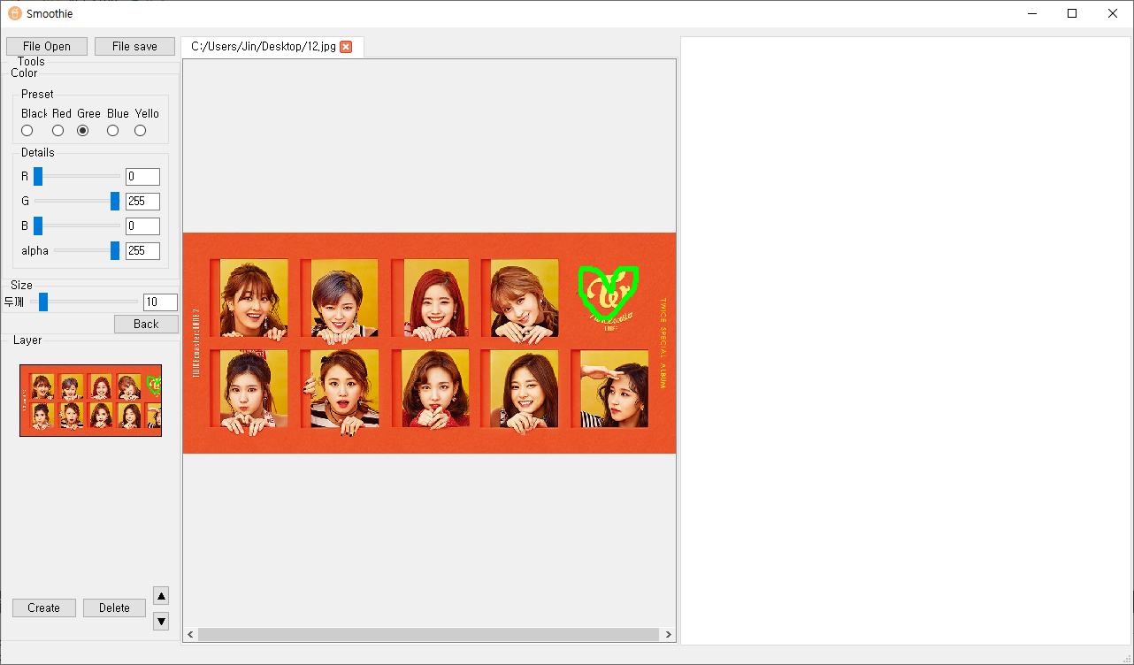

Drawing Function

You can select the pen to use the drawing function.

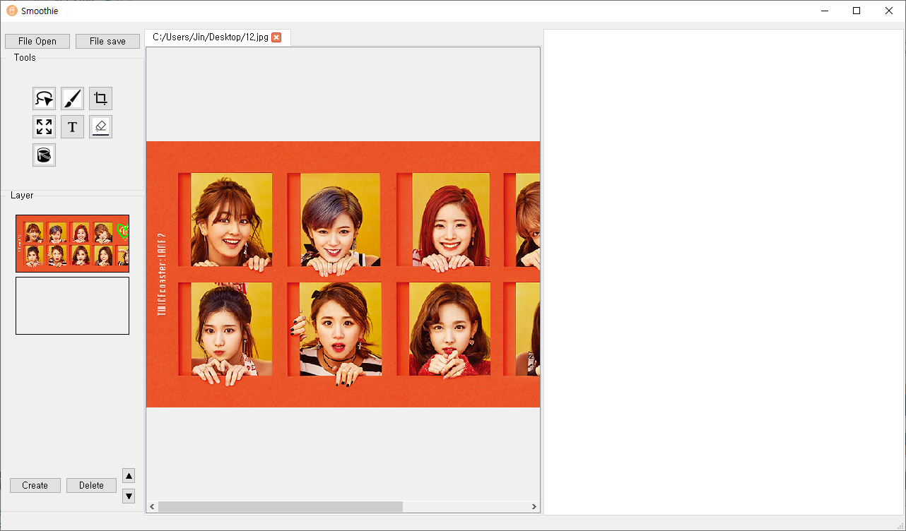

Zoom in & out

Zoom in and out of the picture is made possible through the control and wheel.

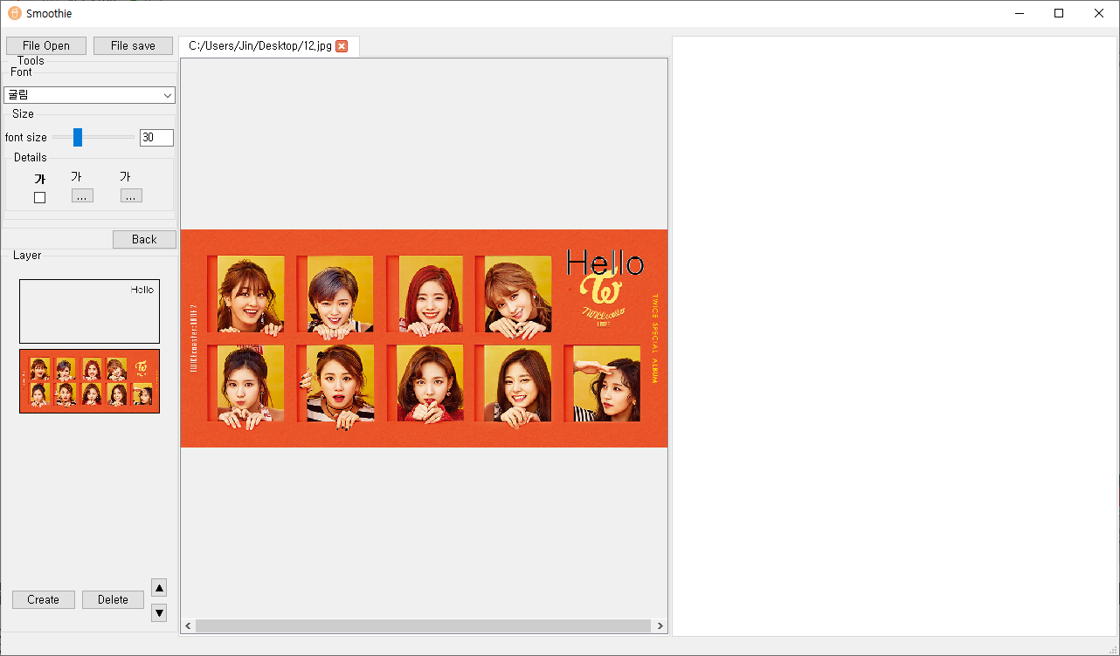

Text Function

As with any other program, you can add text freely. You can also change the background color and the text color.



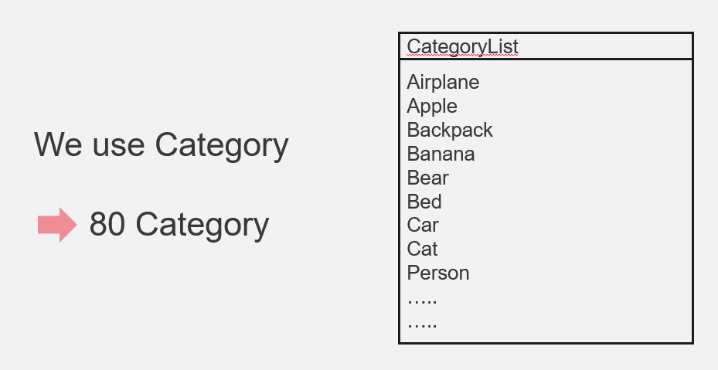

Using the COCO dataset, we created keywords for 80 categories.

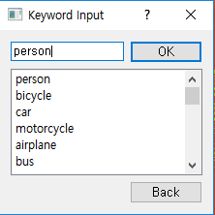

If you enter a keyword, the lasso function works.

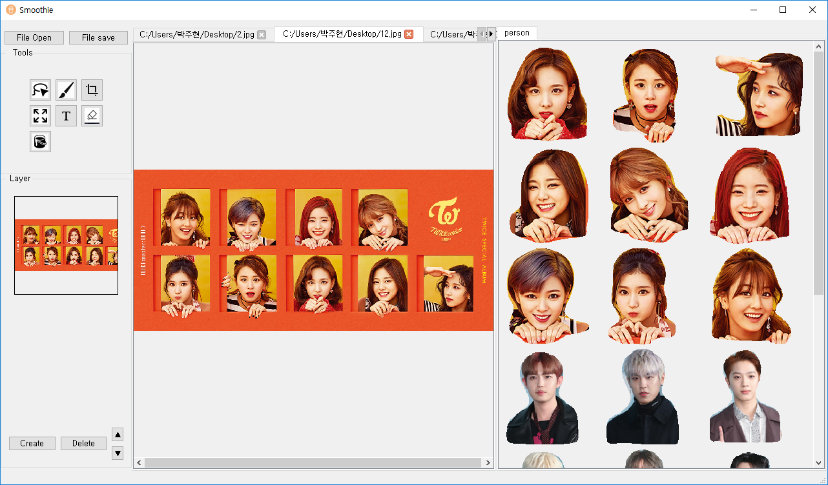

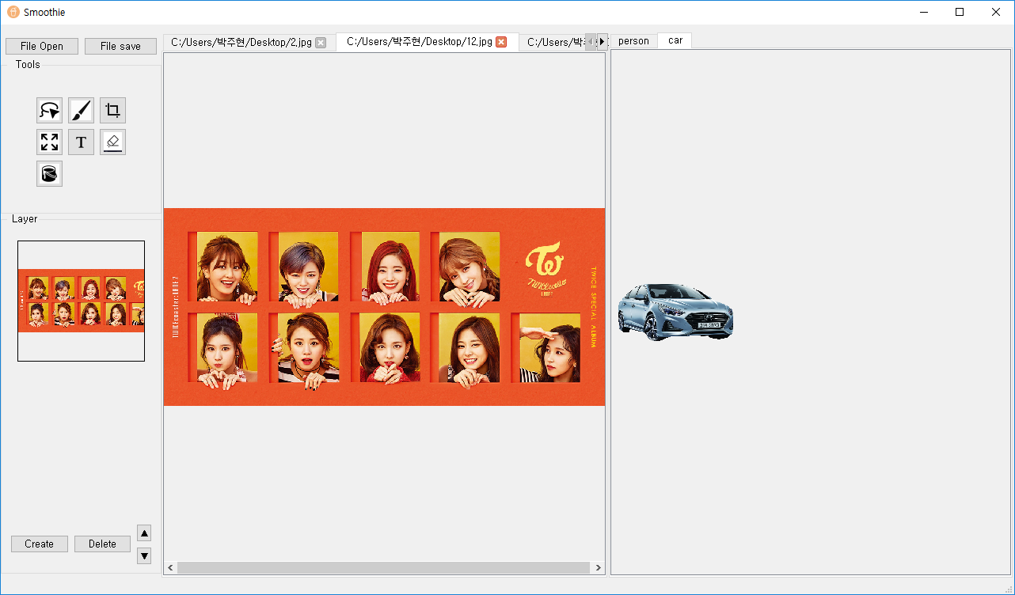

You can get the results when you type person or car.

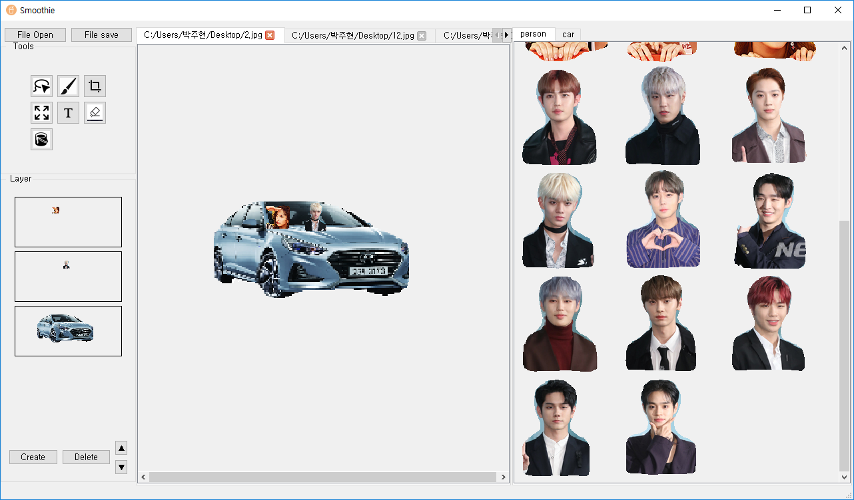

In this way, you can edit the image using it as a sticker.

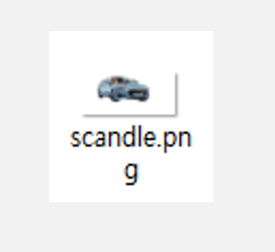

You can save the file in PNG format by saving the file.

1. **Project Result**
   1. **Project completion**

It is satisfactory in terms of completeness because I have implemented all the contents that I intended to implement.

I was a bit worried about the implementation schedule while I was working on the project schedule, but I thunk the finish was good.

* 1. **Survey Summary**

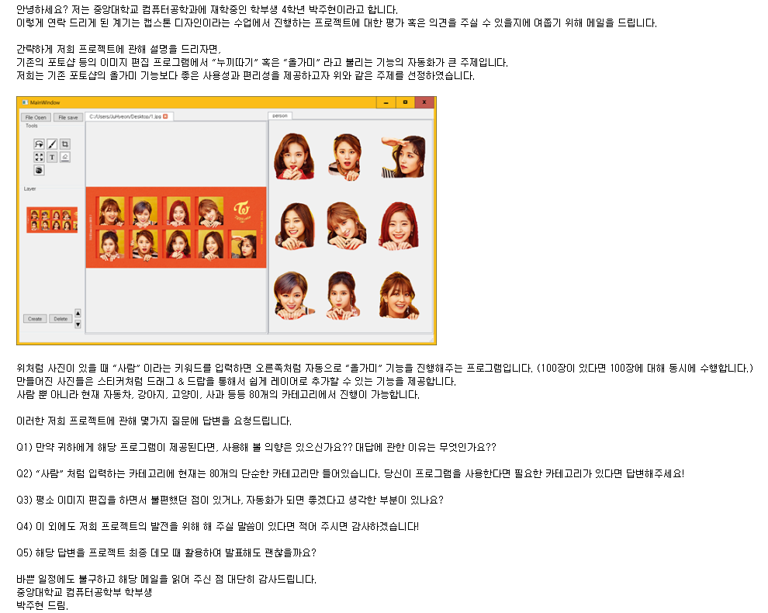

Snow, Adobe Korea, CAU UBS, CAU News, Computer Vision Strat-up company, Game Youtuber, Bora Youtuber, Vlog Youtuber, Baseball club media team, Riot Games, Freelancer, Power Blogger …..

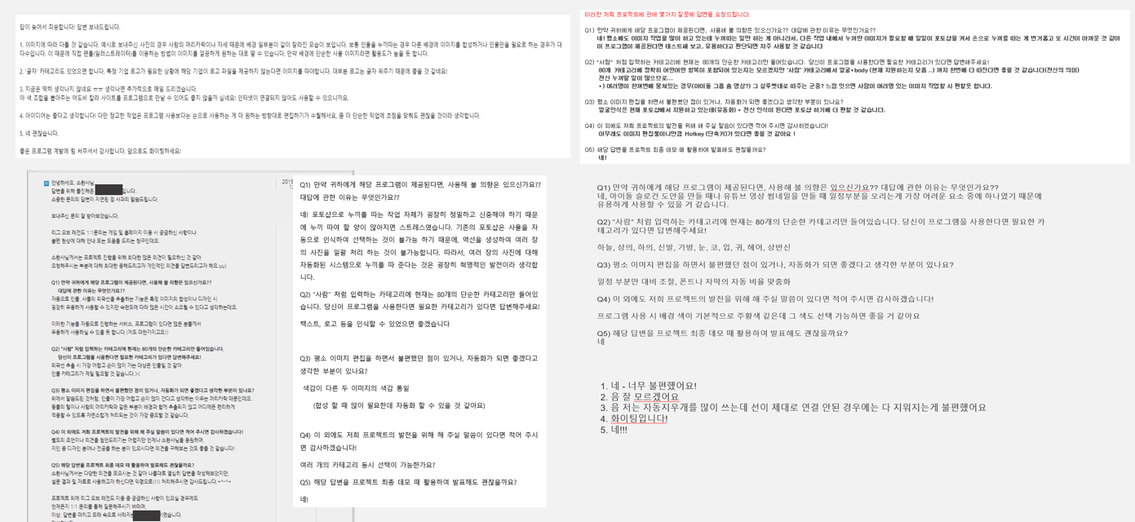

We conducted surveys on people who use a lot of image editing programs.

Q.1. Will you use this program when it is available? If so, why?

Yes for all response. For that reason, Easy to use, Fast to use, Fast to use, other tools are too annoying to use. It seems to be useful because there are a lot of time differences according to proficiency.

Q2. What categories do you need?

Person, shirs, pants, shoes, face, Bust, silhouette, logo, text

Q3. What functions do you want to be developed in photo editing program?

Color matching recommendations or automatic color settings.

Customize auto rate of text or images.

Refining hair part extraction.

Q4. Do you have any additional comments?

Ability to further subdivide extracted photos.

Hot keys.

Focus you sophisticated work on designer work and simple tasks.

* 1. **Future Development Plan**

Based on the questionnaires and feedback, we set up a future development plan.

1. Low-resolution Photograph

The Photograph may be broken at the time of enlargement or reduction. To solve this problem, super resolution can solve the problem.

1. Additional Editing Function

If we add more functions, it is more convenient to use.

* 1. **Reviews**

Park Juhyeon

It was a good project because it was a project that I had done while using the learning model for the first time.

And I respect those who have made image editing programs.

Hong Jin

In this project , using deep learning model is valuable experience. During this semester, I was able to learn how to plan and mange the project by doing presentation every week.

Heo JeongWoo

There were many difficulties because it was my first time to use CNN and create an image editing program. But it was good to finish well. In particular, I felt that I had to do my initial design as I was doing this project and felt that I needed to use Github better.